CO3 AT3
Name:M Deepika
Reg:192311027
Dep:BE.CSE
HOTEL RESERVATION APPLICATION USING JAVA EXCEPTION HANDLING

Aim:

To develop a Hotel Reservation Application in Java that validates booking dates, guest count, and room availability using separate validation methods. The application also demonstrates built-in exceptions, a user-defined exception, throw, throws, try, multiple catch blocks, finally, and safe recovery from invalid inputs.

Objectives

The main objectives of the Hotel Reservation Application are:

1. To develop a hotel room reservation system using Java.
2. To validate the guest name before processing a reservation.
3. To validate the check-in date and prevent invalid or past dates.
4. To validate the number of guests allowed in a room.
5. To verify whether the selected room is available.
6. To create and use a user-defined RoomUnavailableException.
7. To demonstrate the use of throw and throws.
8. To handle built-in exceptions appropriately.
9. To demonstrate try, multiple catch blocks, and finally.
10. To recover safely from invalid input wherever possible.
11. To test the application using both valid and invalid test cases.
12. To display clear error and recovery messages.

Problem Statement

A hotel reservation application must be developed in Java to manage room bookings safely and correctly. During the reservation process, a customer may provide invalid information such as an incorrect date, invalid guest count, null guest name, or an unavailable room number. Therefore, all important inputs must be validated before confirming a reservation.

The application must validate the guest name, check-in date, number of guests, and room availability using separate methods. Invalid data should not cause the complete program to terminate unexpectedly. Instead, suitable Java exception-handling mechanisms should be used to identify the problem and display meaningful messages.

The application should demonstrate built-in exceptions such as NumberFormatException, NullPointerException, ArithmeticException, ArrayIndexOutOfBoundsException, IllegalArgumentException, and IOException wherever relevant.

A user-defined exception called RoomUnavailableException must also be created. This exception should be thrown whenever the selected room is not available. The program must demonstrate the use of throw, throws, try, multiple catch blocks, and finally. Both valid and invalid data must be deliberately tested using multiple test cases.

Requirements

Software Requirements

Operating System: Windows 10 / Windows 11

Programming Language: Java

JDK: JDK 8 or above

Editor/IDE: Visual Studio Code, Eclipse, IntelliJ IDEA, or any Java-supported editor

Compiler: Java Compiler (javac)

Execution Environment: Java Virtual Machine (JVM)

Functional Requirements

1. Validate the guest name.
2. Validate the check-in date.
3. Validate the number of guests.
4. Validate the room number.
5. Check room availability.
6. Confirm a reservation only when all data is valid.
7. Handle invalid input using suitable exceptions.
8. Generate meaningful error messages.
9. Provide safe recovery messages.
10. Execute multiple valid and invalid test cases.

Java Concepts Used
The following Java concepts are used in this application:
1. Classes and objects
2. Constructors
3. Methods
4. Static methods
5. Arrays
6. Conditional statements
7. Exception handling
8. try block
9. Multiple catch blocks
10. finally block
11. throw keyword
12. throws keyword
13. User-defined exception
14. Built-in exceptions
15. LocalDate
16. Date parsing

Class Design

The application consists of three classes.

RoomUnavailableException

RoomUnavailableException is a user-defined exception class. It extends the Exception class and is used when a customer selects a hotel room that is currently unavailable.

HotelReservation

The HotelReservation class represents the reservation information. It contains the guest name, check-in date, guest count, room number, and room availability information.

It also contains separate validation methods for validating the guest name, date, guest count, and room availability.

HotelReservationApp

HotelReservationApp is the main class of the program. It contains the main() method and executes the different valid and invalid test cases.

Validation Methods

validateName()

The validateName() method checks whether the guest name is valid. If the name is null, a NullPointerException is thrown. If the name is empty, an IllegalArgumentException is thrown.

validateDate()

The validateDate() method validates the check-in date. LocalDate.parse() is used to convert the entered String into a date. If the date format is incorrect, an IllegalArgumentException is generated. The method also checks whether the booking date is in the past.

validateGuestCount()

The validateGuestCount() method validates the number of guests. Integer.parseInt() is used to convert the input String into an integer. If a value such as "two" is supplied, a NumberFormatException occurs. The accepted guest count is from 1 to 4.

validateRoom()

The validateRoom() method verifies the room number and room availability. If the room number is outside the available range, an ArrayIndexOutOfBoundsException is generated. If the room exists but is unavailable, RoomUnavailableException is thrown.

calculateCostPerGuest()

This method demonstrates ArithmeticException. The total cost is divided by the number of guests. If the number of guests is zero, division by zero causes an ArithmeticException.

generateConfirmation()

The generateConfirmation() method demonstrates IOException. The method is declared with throws IOException and simulates a situation in which reservation confirmation generation fails.

User-Defined Exception

Java allows programmers to define custom exceptions for application-specific problems. In this application, RoomUnavailableException is created to represent the condition in which a customer selects a room that is already occupied.

The exception class is:

class RoomUnavailableException extends Exception {

public RoomUnavailableException(String message) {
super(message);
}
}

When an unavailable room is selected, the exception is explicitly generated using:

throw new RoomUnavailableException(
"Room " + roomNumber + " is currently unavailable.");

This makes the error message specific to the hotel reservation application.

Use of throw

The throw keyword is used to explicitly generate an exception from a method.

For example:

if (!rooms[roomNumber - 1]) {
throw new RoomUnavailableException(
"Room " + roomNumber + " is currently unavailable.");
}

When the condition becomes true, the program immediately throws RoomUnavailableException.

Use of throws

The throws keyword is used in a method declaration to indicate that the method may pass an exception to its calling method.

For example:

public static void validateRoom(int roomNumber)
throws RoomUnavailableException

Another example is:

public static void generateConfirmation(boolean simulateError)
throws IOException

The calling code must handle these checked exceptions appropriately.

Algorithm:
1. Start the program.
2. Create an array to represent room availability.
3. Create the reservation details.
4. Validate the guest name.
5. Check whether the guest name is null or empty.
6. Validate the check-in date.
7. Convert the entered date into LocalDate.
8. Check whether the date is valid and is not in the past.
9. Validate the guest count.
10. Convert the guest count from String to integer.
11. Check whether the guest count is between 1 and 4.
12. Validate the selected room number.
13. Check whether the room number is within the valid range.
14. Check whether the selected room is available.
15. If the room is unavailable, throw RoomUnavailableException.
16. If all validation succeeds, confirm the reservation.
17. Mark the selected room as unavailable.
18. Display the reservation details.
19. Catch any exception that occurs.
20. Display an appropriate error and recovery message.
21. Execute the finally block.
22. Execute additional valid and invalid test cases.
23. Stop the program.

Pseudocode

START

Create room availability array

FUNCTION validateName(name)

IF name is null
THROW NullPointerException
END IF

IF name is empty
THROW IllegalArgumentException
END IF

END FUNCTION

FUNCTION validateDate(date)

TRY
Convert date into LocalDate

IF date is before current date
THROW IllegalArgumentException
END IF

CATCH invalid date format
THROW IllegalArgumentException
END TRY

END FUNCTION

FUNCTION validateGuestCount(input)

Convert input into integer

IF guest count <= 0
THROW IllegalArgumentException
END IF

IF guest count > 4
THROW IllegalArgumentException
END IF

RETURN guest count

END FUNCTION

FUNCTION validateRoom(roomNumber)

IF room number is outside valid range
THROW ArrayIndexOutOfBoundsException
END IF

IF room is unavailable
THROW RoomUnavailableException
END IF

END FUNCTION

FUNCTION makeReservation()

TRY
Validate guest name
Validate date
Validate guest count
Validate room availability

Mark room as unavailable
Display reservation successful message

CATCH NullPointerException
Display guest name error

CATCH RoomUnavailableException
Display room availability error

CATCH ArrayIndexOutOfBoundsException
Display room number error

CATCH IllegalArgumentException
Display validation error

FINALLY
Display reservation process completed

END FUNCTION

Execute valid and invalid test cases

STOP

Source Code
File Name: HotelReservationApp.java
import java.io.IOException;
import java.time.LocalDate;
import java.time.format.DateTimeParseException;

class RoomUnavailableException extends Exception {

public RoomUnavailableException(String message) {
super(message);
}
}
class HotelReservation {
private String guestName;
private String checkInDate;
private int guestCount;
private int roomNumber;

private static boolean[] rooms =
{true, true, false, true, false};

public HotelReservation(String guestName,
String checkInDate,
int guestCount,
int roomNumber) {

this.guestName = guestName;
this.checkInDate = checkInDate;
this.guestCount = guestCount;
this.roomNumber = roomNumber;
}

public static void validateName(String name) {

if (name == null) {
throw new NullPointerException(
"Guest name cannot be null.");
}

if (name.trim().isEmpty()) {
throw new IllegalArgumentException(
"Guest name cannot be empty.");
}

System.out.println(
"Guest name is valid: " + name);
}

public static void validateDate(String date) {

try {

LocalDate bookingDate =
LocalDate.parse(date);

if (bookingDate.isBefore(LocalDate.now())) {
throw new IllegalArgumentException(
"Booking date cannot be in the past.");
}

System.out.println(
"Date is valid: " + bookingDate);

} catch (DateTimeParseException e) {

throw new IllegalArgumentException(
"Invalid date format. Use YYYY-MM-DD.");
}
}

public static int validateGuestCount(String input) {

int guests = Integer.parseInt(input);

if (guests <= 0) {
throw new IllegalArgumentException(
"Guest count must be greater than zero.");
}

if (guests > 4) {
throw new IllegalArgumentException(
"Maximum 4 guests are allowed per room.");
}

System.out.println(
"Guest count is valid: " + guests);

return guests;
}

public static void validateRoom(int roomNumber)
throws RoomUnavailableException {

if (roomNumber < 1 || roomNumber > rooms.length) {

throw new ArrayIndexOutOfBoundsException(
"Room number must be between 1 and "
+ rooms.length + ".");
}

if (!rooms[roomNumber - 1]) {

throw new RoomUnavailableException(
"Room " + roomNumber
+ " is currently unavailable.");
}

System.out.println(
"Room " + roomNumber + " is available.");
}

public static void calculateCostPerGuest(
int totalCost, int guests) {

int costPerGuest = totalCost / guests;

System.out.println(
"Cost per guest = Rs." + costPerGuest);
}

public static void generateConfirmation(
boolean simulateError)
throws IOException {

if (simulateError) {

throw new IOException(
"Unable to generate reservation confirmation.");
}

System.out.println(
"Reservation confirmation generated successfully.");
}

public void makeReservation() {

try {

validateName(guestName);
validateDate(checkInDate);

if (guestCount <= 0) {
throw new IllegalArgumentException(
"Guest count is invalid.");
}

validateRoom(roomNumber);

rooms[roomNumber - 1] = false;

System.out.println();
System.out.println("RESERVATION SUCCESSFUL");
System.out.println("Guest Name : " + guestName);
System.out.println("Check-in : " + checkInDate);
System.out.println("Guests : " + guestCount);
System.out.println("Room No : " + roomNumber);

} catch (NullPointerException e) {

System.out.println(
"NullPointerException: "
+ e.getMessage());

System.out.println(
"Recovery: Enter a valid guest name.");

} catch (RoomUnavailableException e) {

System.out.println(
"RoomUnavailableException: "
+ e.getMessage());

System.out.println(
"Recovery: Select another available room.");

} catch (ArrayIndexOutOfBoundsException e) {

System.out.println(
"Array Exception: "
+ e.getMessage());

System.out.println(
"Recovery: Enter a valid room number.");

} catch (IllegalArgumentException e) {

System.out.println(
"Validation Error: "
+ e.getMessage());

System.out.println(
"Recovery: Correct the invalid input.");

} finally {

System.out.println(
"Reservation attempt completed.");

System.out.println(
"--------------------------------");
}
}
}

public class HotelReservationApp {

public static void main(String[] args) {

System.out.println(
"HOTEL RESERVATION APPLICATION");

System.out.println(
"=============================");

// Test Case 1 - Valid Reservation

System.out.println(
"\nTEST CASE 1: VALID RESERVATION");

try {

int guests =
HotelReservation.validateGuestCount("2");

HotelReservation reservation1 =
new HotelReservation(
"Deepika",
"2026-12-20",
guests,
1);

reservation1.makeReservation();

} catch (NumberFormatException e) {

System.out.println(
"NumberFormatException: "
+ e.getMessage());

} catch (Exception e) {

System.out.println(
"Unexpected Error: "
+ e.getMessage());
}

// Test Case 2 - Invalid Guest Count

System.out.println(
"\nTEST CASE 2: INVALID GUEST COUNT");

try {

int guests =
HotelReservation.validateGuestCount("two");

HotelReservation reservation2 =
new HotelReservation(
"Anu",
"2026-12-22",
guests,
2);

reservation2.makeReservation();

} catch (NumberFormatException e) {

System.out.println(
"NumberFormatException: "
+ "Guest count must be a number.");

System.out.println(
"Recovery: Enter guest count such as 1, 2, 3 or 4.");

} catch (IllegalArgumentException e) {

System.out.println(
"Guest Count Error: "
+ e.getMessage());

} finally {

System.out.println(
"Guest-count validation completed.");
}

// Test Case 3 - Unavailable Room

System.out.println(
"\nTEST CASE 3: ROOM UNAVAILABLE");

try {

int guests =
HotelReservation.validateGuestCount("3");

HotelReservation reservation3 =
new HotelReservation(
"Lakshmi",
"2026-12-25",
guests,
3);

reservation3.makeReservation();

} catch (NumberFormatException e) {

System.out.println(
"Number Format Error: "
+ e.getMessage());
}

// Test Case 4 - Null Guest Name

System.out.println(
"\nTEST CASE 4: NULL GUEST NAME");

HotelReservation reservation4 =
new HotelReservation(
null,
"2026-12-28",
2,
4);

reservation4.makeReservation();

// Test Case 5 - Arithmetic Exception

System.out.println(
"\nTEST CASE 5: ARITHMETIC EXCEPTION");

try {

HotelReservation.calculateCostPerGuest(
5000, 0);

} catch (ArithmeticException e) {

System.out.println(
"ArithmeticException: "
+ "Cannot divide cost by zero guests.");

System.out.println(
"Recovery: Enter at least one guest.");

} finally {

System.out.println(
"Cost calculation attempt completed.");
}

// Test Case 6 - IOException

System.out.println(
"\nTEST CASE 6: IO EXCEPTION");

try {

HotelReservation.generateConfirmation(true);

} catch (IOException e) {

System.out.println(
"IOException: " + e.getMessage());

System.out.println(
"Recovery: Confirmation can be generated later.");

} finally {

System.out.println(
"Confirmation process completed.");
}

// Test Case 7 - Invalid Room Number

System.out.println(
"\nTEST CASE 7: INVALID ROOM NUMBER");

try {

HotelReservation.validateRoom(10);

} catch (RoomUnavailableException e) {

System.out.println(
"RoomUnavailableException: "
+ e.getMessage());

} catch (ArrayIndexOutOfBoundsException e) {

System.out.println(
"ArrayIndexOutOfBoundsException: "
+ e.getMessage());

System.out.println(
"Recovery: Select a room between 1 and 5.");

} finally {

System.out.println(
"Room validation completed.");
}

System.out.println(
"\nPROGRAM FINISHED SUCCESSFULLY");
}
}

Exception Handling

NumberFormatException

NumberFormatException occurs when the program attempts to convert an invalid String into an integer. In this program, the value "two" is deliberately supplied as the guest count. Since "two" cannot be converted into an integer using Integer.parseInt(), NumberFormatException occurs. The exception is caught and the user is informed to enter a numeric guest count.

NullPointerException

NullPointerException is demonstrated when the guest name is null. The validateName() method explicitly checks for a null guest name and throws NullPointerException. The exception is handled and the program displays a recovery message asking for a valid guest name.

IllegalArgumentException

IllegalArgumentException is used when an input has an unacceptable value. It is used for an empty guest name, a past booking date, a guest count less than or equal to zero, and a guest count greater than four.

ArithmeticException

ArithmeticException occurs when an invalid arithmetic operation is performed. In the program, the total cost of Rs.5000 is deliberately divided by zero guests. The exception is caught and the program displays a message requesting at least one guest.

ArrayIndexOutOfBoundsException
The program contains five hotel rooms. If a room number outside the valid range is supplied, an ArrayIndexOutOfBoundsException is generated. Test Case 7 deliberately uses Room 10 to demonstrate this condition.
IOException
IOException is a checked exception. The generateConfirmation() method is declared using throws IOException. A simulated failure is deliberately generated to demonstrate how an I/O-related error can be handled.
RoomUnavailableException
RoomUnavailableException is the user-defined exception created specifically for this hotel reservation application. It is thrown when a customer selects a room that is currently unavailable. The application catches the exception and advises the customer to choose another available room.
Multiple Catch Blocks
The application demonstrates multiple catch blocks. A single try block may produce different exceptions depending on the type of invalid input. Each exception is handled separately so that a meaningful error message can be displayed.

For example:
try {

validateName(guestName);
validateDate(checkInDate);
validateRoom(roomNumber);

}

catch (NullPointerException e) {

System.out.println("Invalid guest name.");

}

catch (RoomUnavailableException e) {

System.out.println("Room is unavailable.");

}

catch (ArrayIndexOutOfBoundsException e) {

System.out.println("Invalid room number.");

}

catch (IllegalArgumentException e) {

System.out.println("Invalid input.");

}
Use of finally
The finally block executes regardless of whether an exception occurs. It is generally used for cleanup operations such as closing files, closing database connections, releasing resources, or displaying final status information.
In this program, finally is used to indicate that a particular reservation or validation attempt has been completed.
Safe Recovery
The program provides safe recovery wherever possible. Instead of terminating immediately after invalid input, the exception is caught and a meaningful message is displayed.
For example, if the guest count is entered as "two", the application catches NumberFormatException and displays:
Guest count must be a number.
It also displays the recovery message:
Enter guest count such as 1, 2, 3 or 4.
Similarly, if an unavailable room is selected, the program advises the user to select another available room.
This makes the application more reliable and user-friendly.
Test Cases
Test Case 1: Valid Reservation
Guest Name: Deepika
Check-in Date: 2026-12-20
Guest Count: 2
Room Number: 1
Expected Result: Reservation should be completed successfully.
Actual Result: Reservation completed successfully.
Status: PASS
Test Case 2: Invalid Guest Count
Guest Name: Anu
Check-in Date: 2026-12-22
Guest Count: two
Room Number: 2
Expected Result: NumberFormatException should be handled.
Actual Result: NumberFormatException is caught and a recovery message is displayed.
Status: PASS
Test Case 3: Unavailable Room
Guest Name: Lakshmi
Check-in Date: 2026-12-25
Guest Count: 3
Room Number: 3
Expected Result: RoomUnavailableException should occur.
Actual Result: RoomUnavailableException is successfully handled.
Status: PASS
Test Case 4: Null Guest Name
Guest Name: null
Check-in Date: 2026-12-28
Guest Count: 2
Room Number: 4
Expected Result: NullPointerException should occur.
Actual Result: NullPointerException is handled successfully.
Status: PASS
Test Case 5: Arithmetic Exception
Total Cost: Rs.5000
Guest Count: 0
Expected Result: ArithmeticException should occur.
Actual Result: ArithmeticException is caught successfully.
Status: PASS
Test Case 6: IOException
Input: simulateError = true
Expected Result: IOException should occur.

Actual Result: IOException is caught and a recovery message is displayed.
Status: PASS
Test Case 7: Invalid Room Number
Room Number: 10
Valid Room Range: 1 to 5
Expected Result: ArrayIndexOutOfBoundsException should occur.
Actual Result: ArrayIndexOutOfBoundsException is caught successfully.
Status: PASS
Sample Output:
HOTEL RESERVATION APPLICATION
=============================
TEST CASE 1: VALID RESERVATION
Guest count is valid: 2
Guest name is valid: Deepika
Date is valid: 2026-12-20
Room 1 is available.
RESERVATION SUCCESSFUL
Guest Name : Deepika
Check-in : 2026-12-20
Guests : 2
Room No : 1
Reservation attempt completed.

TEST CASE 2: INVALID GUEST COUNT
NumberFormatException: Guest count must be a number.
Recovery: Enter guest count such as 1, 2, 3 or 4.
Guest-count validation completed.

TEST CASE 3: ROOM UNAVAILABLE
Guest count is valid: 3
Guest name is valid: Lakshmi
Date is valid: 2026-12-25
RoomUnavailableException: Room 3 is currently unavailable.
Recovery: Select another available room.
Reservation attempt completed.

TEST CASE 4: NULL GUEST NAME
NullPointerException: Guest name cannot be null.
Recovery: Enter a valid guest name.
Reservation attempt completed.

TEST CASE 5: ARITHMETIC EXCEPTION
ArithmeticException: Cannot divide cost by zero guests.
Recovery: Enter at least one guest.
Cost calculation attempt completed.

TEST CASE 6: IO EXCEPTION
IOException: Unable to generate reservation confirmation.
Recovery: Confirmation can be generated later.
Confirmation process completed.

TEST CASE 7: INVALID ROOM NUMBER
ArrayIndexOutOfBoundsException: Room number must be between 1 and 5.
Recovery: Select a room between 1 and 5.
Room validation completed.
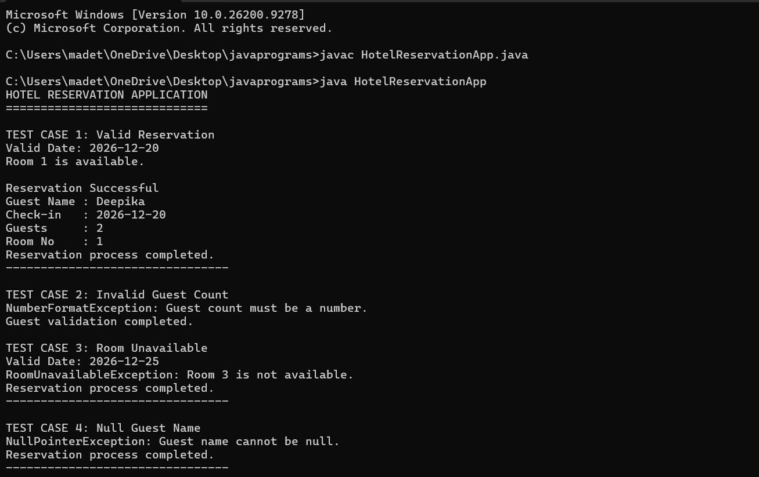
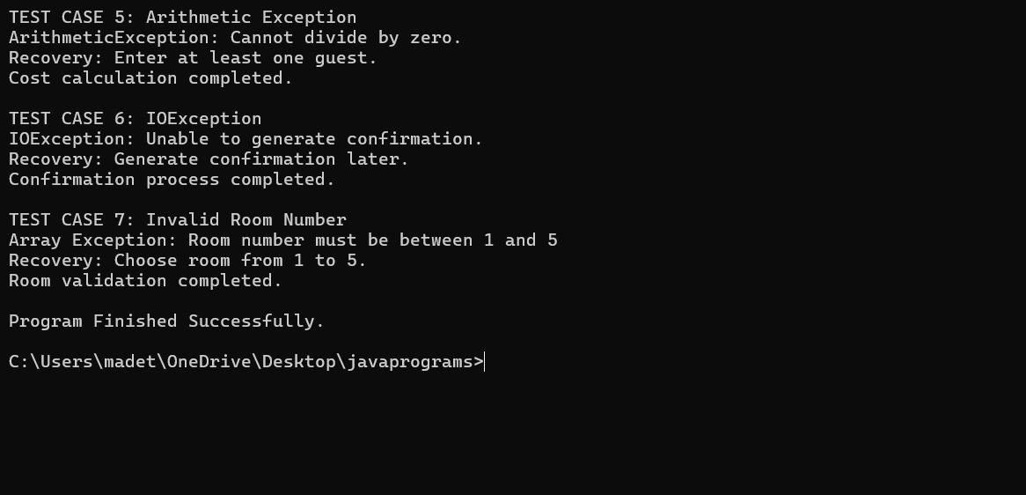

PROGRAM FINISHED SUCCESSFULLY
Advantages:
1. The application prevents invalid hotel reservations.
2. Each important input is validated using a separate method.
3. Exception handling prevents unexpected program termination.
4. The custom exception clearly represents room availability problems.
5. Multiple catch blocks provide specific handling for different errors.
6. The finally block ensures completion activities are performed.
7. Both checked and unchecked exceptions are demonstrated.
8. The program is modular and easy to understand.
9. Additional validation rules can be added easily.
10. Clear recovery messages improve usability.

Limitations:
1. The program currently represents only five rooms.
2. Room availability is stored temporarily in an array.
3. Reservation information is lost when the application terminates.
4. No database is used.
5. Room categories are not included.
6. Check-out date validation is not implemented.
7. Online payment is not supported.
8. Customer authentication is not implemented.
9. IOException is simulated for exception-handling demonstration.
10. The program uses predefined test cases rather than a graphical user interface.

Future Enhancements:

The application can be extended by adding a MySQL database to permanently store reservation details. A Java Swing or JavaFX interface can be developed to provide a graphical reservation system. Customer login, administrator login, room categories, check-in and check-out dates, automatic room allocation, online payments, cancellation, refund processing, email confirmation, SMS notifications, invoice generation, and booking history can also be implemented.

Result:

The Hotel Reservation Application was successfully developed using Java. The program validates the guest name, check-in date, guest count, room number, and room availability.

The application successfully demonstrates NumberFormatException, NullPointerException, IllegalArgumentException, ArithmeticException, ArrayIndexOutOfBoundsException, and IOException. A user-defined RoomUnavailableException is also created and handled successfully.

The use of try, multiple catch blocks, finally, throw, and throws is demonstrated. Both valid and invalid test cases are executed, and the application provides appropriate error and recovery messages.
Conclusion:
The Hotel Reservation Application demonstrates the effective use of Java exception handling in a practical reservation system. Important reservation information is validated using separate methods before the booking is confirmed.
Built-in exceptions are used to handle invalid numeric input, null values, invalid arguments, arithmetic errors, invalid array access, and I/O failures. The custom RoomUnavailableException provides application-specific handling when a customer selects an unavailable hotel room.
The throw keyword is used to explicitly generate exceptions, while the throws keyword is used to declare exceptions that may be passed to calling methods. The try, multiple catch, and finally blocks ensure that errors are handled gracefully.
The deliberate execution of valid and invalid test cases confirms that the application can detect incorrect data, display clear messages, and provide safe recovery wherever possible. Therefore, the program successfully satisfies the requirements of a Java-based Hotel Reservation Application with comprehensive exception handling.
Compilation and Execution
Save the Java source code using the following file name:
HotelReservationApp.java
Open Command Prompt in the folder where the file is saved.
Compile the program using:
javac HotelReservationApp.java
Run the program using:
java HotelReservationApp

